Raj Kumar Rao dacing...!!

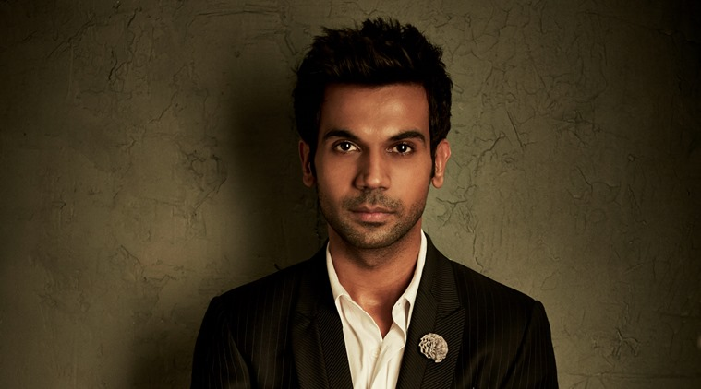As we all know that Raj Kumar Rao is a very versatile actor, from “Love Sex or Dhoka” to his role in “Kai Po Che” as Govind. He has done different sorts of films.  
This time Raj Kumar Rao is all set to play the role Pritam Vidrohi in forthcoming film “Bareilly ki Barfi”. When asked how much he enjoyed his new character at the music launch of the movie, he said, “As an actor, I try and do different thing in every film. Otherwise, it gils really boring. When Nitish sir narrated me the script and when Ashwin said me about the story. I was damn excited. I felt that this character is quite special and unique”.

The actor added he would love to be seen in a typical Bollywood film that involves dance and music. Rajkumar will be seen dancing along with stars Kriti Sanon and Ayushman Khurana.